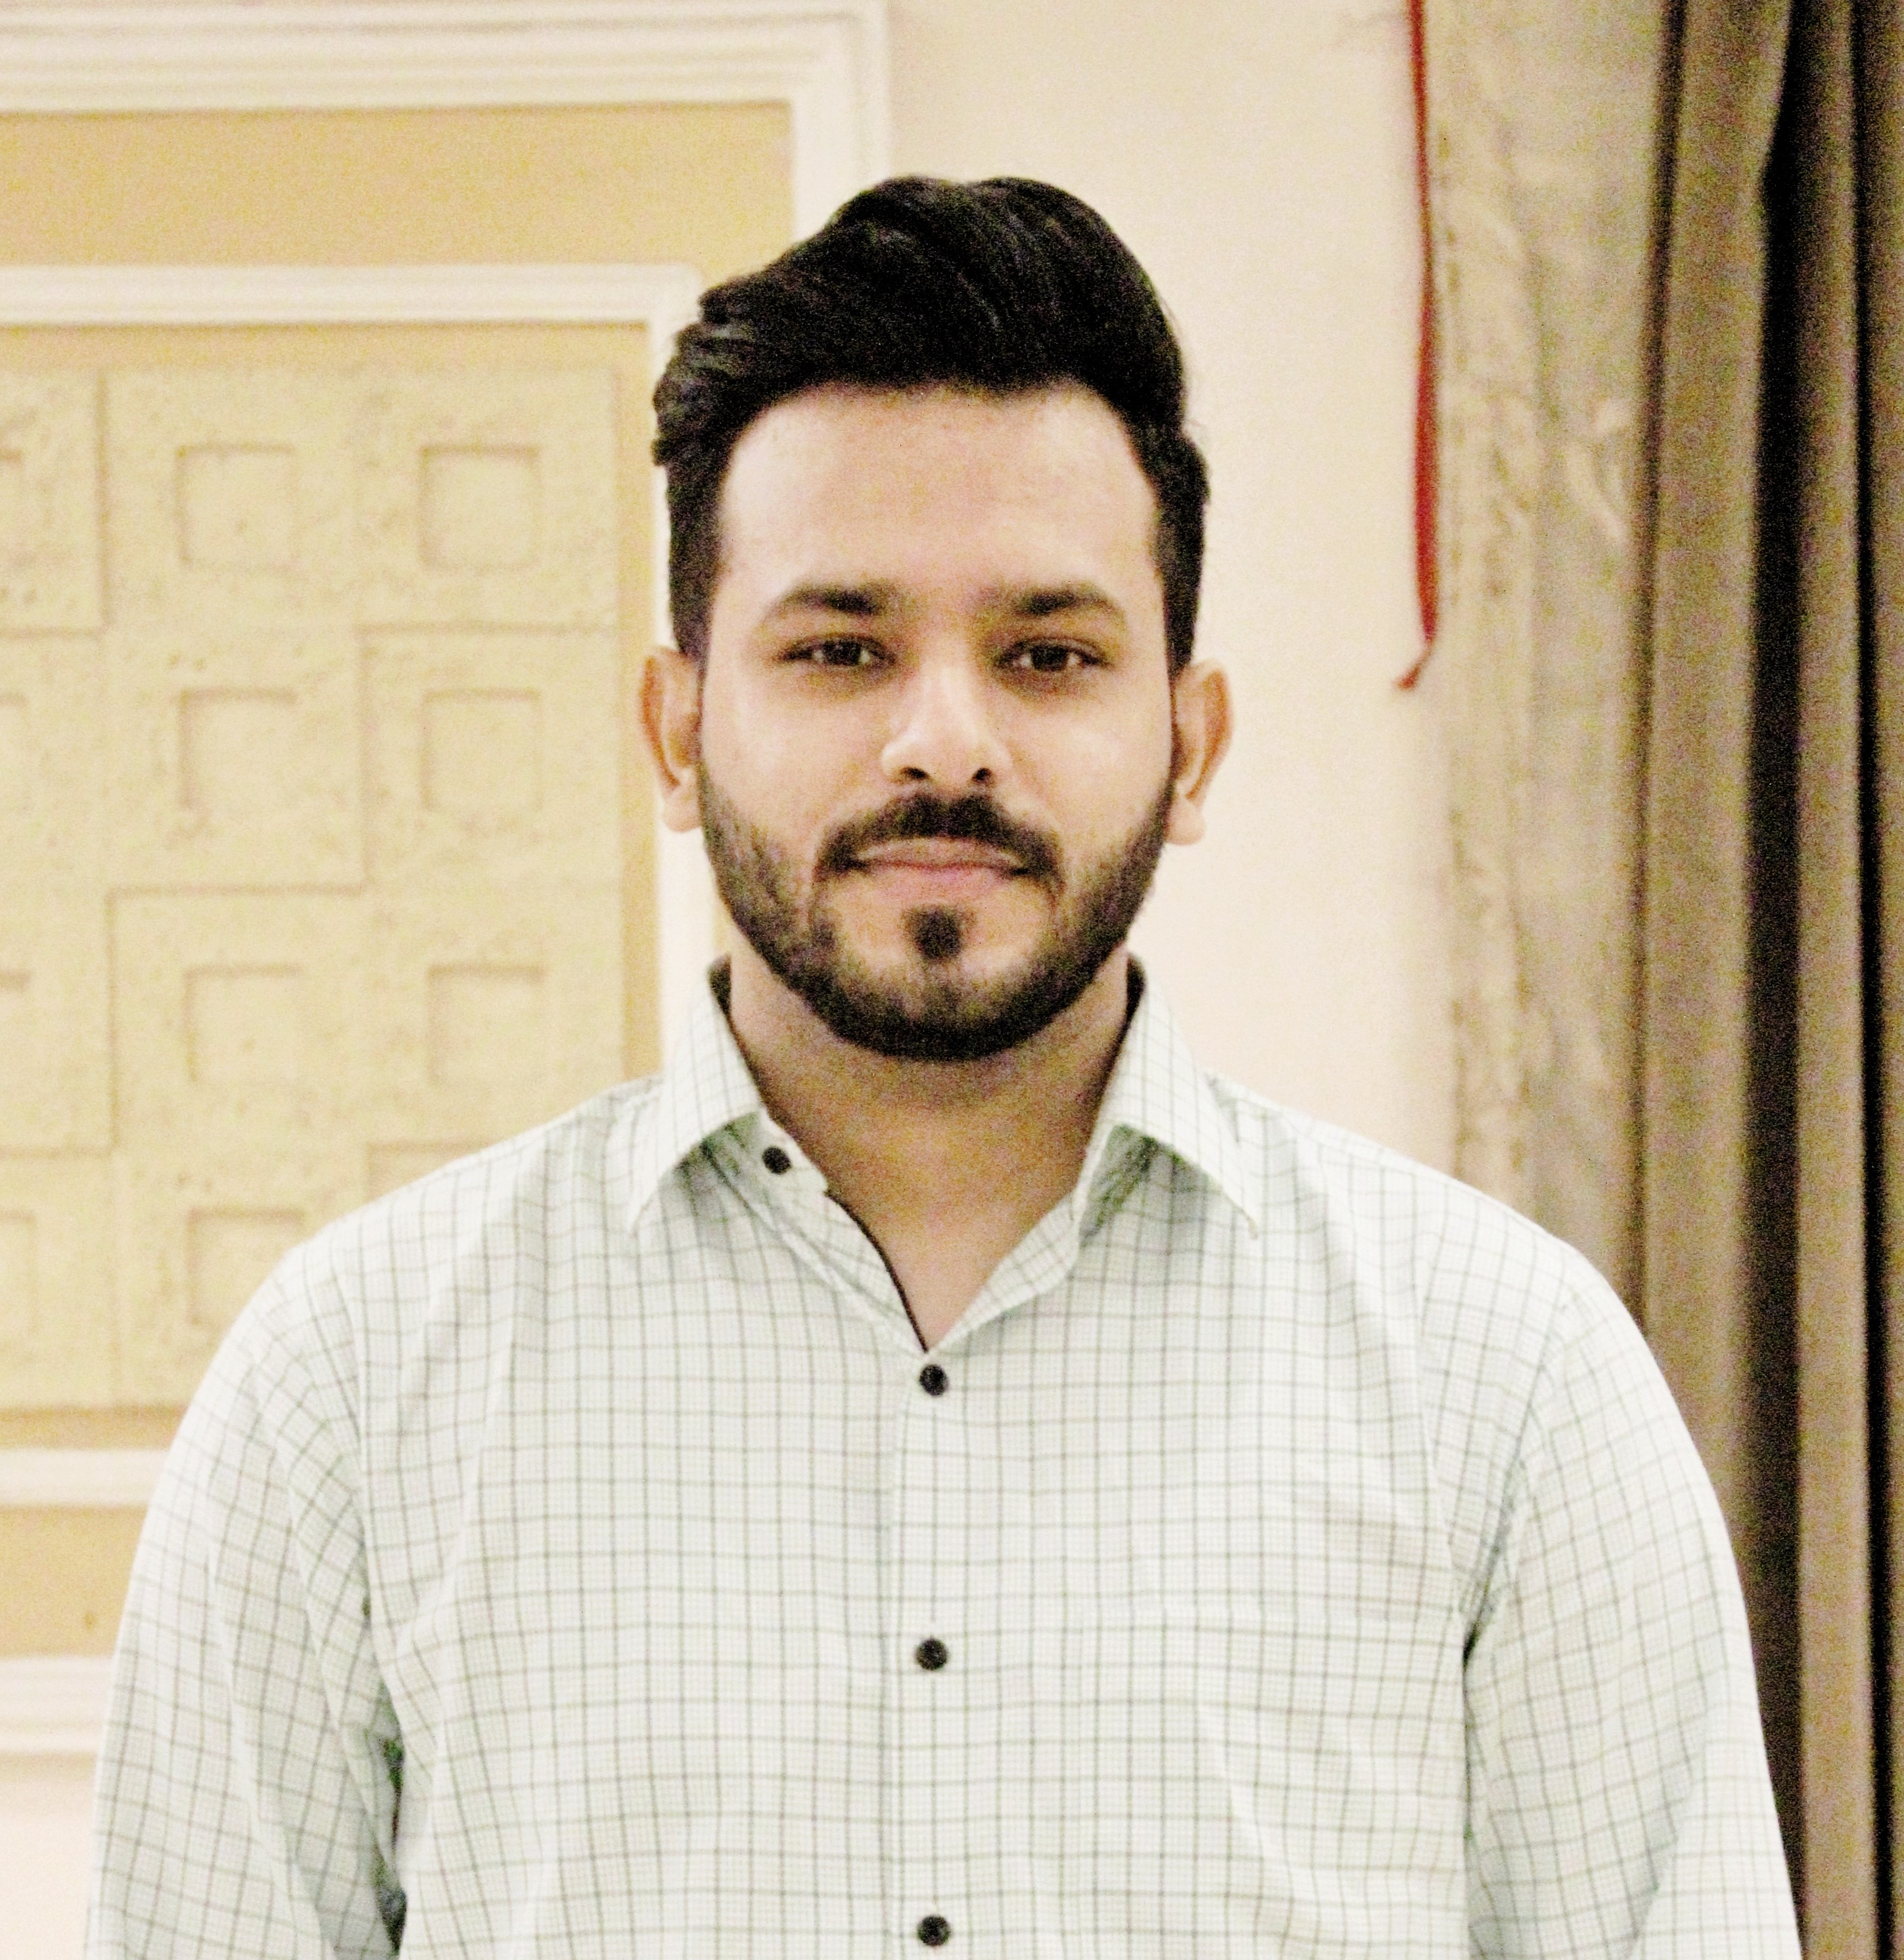 |  |  |  | MUHAMMAD SHAHERYAR

Experience
6 Months
Internship • Front End Developer • House of Professionals (Pvt.) Ltd.
Jan. 2018 – Feb. 2020 (2 Year 2 Months)
BPO • Backend Support Executive • Abacus Consulting (Pvt.) Ltd.
Jul. 2017 – Dec. 2017 (6 Months)
Marketing • Sales Promoter • Brand Logics (Pvt.) Ltd.
Jun 2016 – May. 2017 (1 Year)
Marketing • Brand Ambassador • Helium (Pvt.) Ltd.
Feb. 2015 – Jun. 2016 (1.5 Year)
Front End Cashier • Cashier • Hyperstar
“My exposure in the work area had been very promising. During my tenure with these companies, I handled major responsibilities.”

Education
Certificate in Web Development – House of Professionals
DIT (Diploma in Information Technology) – TEVTA
B.Com (IT) – University of the Punjab
I.Com – BISE LAHORE
Matric – BISE LAHORE

Skills
- HTML 5 / CSS 3, Bootstrap 4, JavaScript, JQuery
- WordPress & CMS Experience
- Business Communication Skills
- Consumer Behavior Insights
- Business Development Skills
- Adobe Photoshop
- MS Office

Interests
Computer programming, Business development activities, Traveling, Playing Chess.

Reference
Will be furnished on demand.
House No. 13-S-9C, Waqar Street No. 1, New Abadi Harbanspura
Lahore
 |  | 0335-4295611
 |  | ishery81.is@gmail.com

